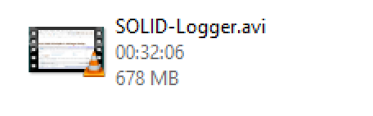
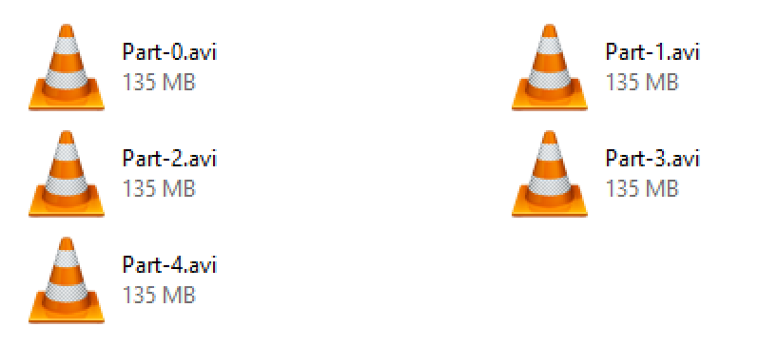
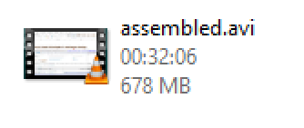
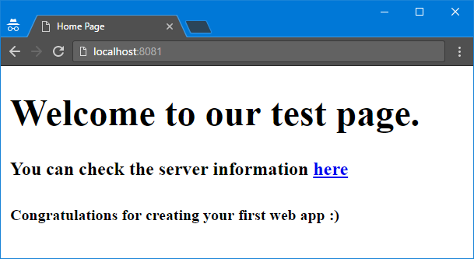
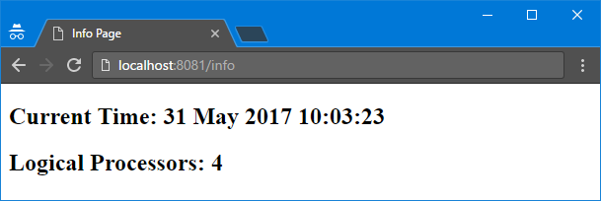
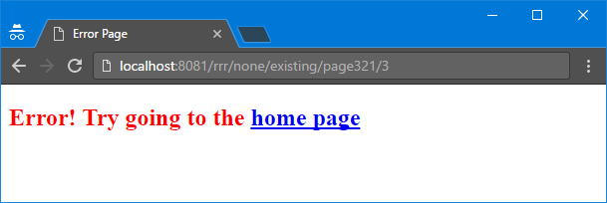

Exercise: Streams and Files
Problems for exercises and homework for the "CSharp Advanced" course @ Software University.

Odd Lines
Write a program that reads a text file and prints on the console its odd lines. Line numbers start from 0. Use StreamReader.
text.txt | Output
-I was quick to judge him, but it wasn't his fault.  -Is this some kind of joke?! Is it?  -Quick, hide here…It is safer. | -Is this some kind of joke?! Is it?

Line Numbers
Write a program that reads a text file and inserts line numbers in front of each of its lines. The result should be written to another text file. Use StreamReader in combination with StreamWriter.
text.txt | output.txt
-I was quick to judge him, but it wasn't his fault.  -Is this some kind of joke?! Is it?  -Quick, hide here…It is safer. | Line 1: -I was quick to judge him, but it wasn't his fault.  Line 2: -Is this some kind of joke?! Is it?  Line 3: -Quick, hide here…It is safer.

Word Count
Write a program that reads a list of words from the file words.txt and finds how many times each of the words is contained in another file text.txt. Matching should be case-insensitive.
Write the results in file results.txt. Sort the words by frequency in descending order. Use StreamReader in combination with StreamWriter.
words.txt | text.txt | result.txt
quick  is  fault | -I was quick to judge him, but it wasn't his fault.  -Is this some kind of joke?! Is it?  -Quick, hide here…It is safer. | is - 3  quick - 2  fault - 1

Copy Binary File
Write a program that copies the contents of a binary file (e.g. image, video, etc.) to another using FileStream. You are not allowed to use the File class or similar helper classes.

Slicing File
Write a program that takes any file and slices it to n parts. Write the following methods:
- Slice(string sourceFile, string destinationDirectory, int parts) - slices the given source file into n parts and saves them in destinationDirectory.
Source File | Destination Directory
parts = 5

- Assemble(List<string> files, string destinationDirectory) - combines all files into one, in the order they are passed, and saves the result in destinationDirectory.
Source Files | Destination Directory

Use FileStreams. You are not allowed to use the File class or similar helper classes.

Zipping Sliced Files
Modify your previous program to also compress the bytes while slicing parts and decompress them when assembling them back to the original file. Use GzipStream.
Tip: When getting files from directory, make sure you only get files with .gz extension (there might be hidden files).
Source File | Compressed & Sliced | Decompressed & Assembled
parts = 5

Directory Traversal
Traverse a given directory for all files with the given extension. Search through the first level of the directory only and write information about each found file in report.txt.
The files should be grouped by their extension. Extensions should be ordered by the count of their files descending, then by name alphabetically.
Files under an extension should be ordered by their size.
report.txt should be saved on the Desktop. Ensure the desktop path is always valid, regardless of the user.
Input | Directory View | report.txt
. |  | .cs  --Mecanismo.cs - 0.994kb  --Program.cs - 1.108kb  --Nashmat.cs - 3.967kb  --Wedding.cs - 23.787kb  --Program - Copy.cs - 35.679kb  --Salimur.cs - 588.657kb  .txt  --backup.txt - 0.028kb  --log.txt - 6.72kb  .asm  --script.asm - 0.028kb  .config  --App.config - 0.187kb  .csproj  --01. Writing-To-Files.csproj - 2.57kb  .js  --controller.js - 1635.143kb  .php  --model.php - 0kb

* Full Directory Traversal
Modify your previous program to recursively traverse the sub-directories of the starting directory as well.

** HTTP Server
Create a simple HTTP server that should be able to receive requests and return appropriate responses accordingly to the request path. Read more on the internet to see what HTTP request and response should look like. Create a web site of 3 pages:
- 1st page should be accessible at localhost:{port}/ - (that is the root directory). That page holds just welcome message and link to the second page
- 2nd page should be accessible at localhost:{port}/info – that page shows the current time and the count of logical processors on the machine
- 3rd page should be an error page if the user tries to access any other page return as response the error page.
You are provided with some HTML files of the needed pages to make it easier for you. You are free to modify them and even use your own HTML files.

Examples

